DbViZ
Test Case: Switch Between Open Diagrams

Identifier Number: b3
Category: Functional

Version <1.0>

Revision History
Date | Version | Description | Author
12-May-2003 | 1.0 | Created. | Aleksandra Faust

Test Case: Switch Between Open Diagrams

Introduction

This test case describes how to test context switching between two diagrams. It supposes that two different diagrams are opened, that zooming, and auto arrange options are setup differently.

Flow of Events

- Import test schema.
R. The system will create an unnamed diagram.
- Set zoom factor to 67%, add all the tables to the diagram, and choose auto arrange option.
  - The system response will look like this:
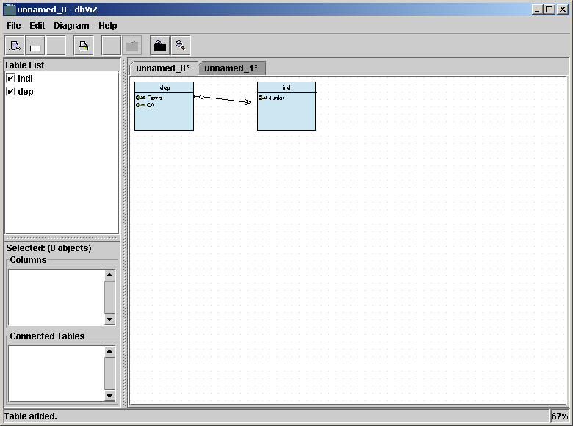
3. Import another test schema and add only one table to it. Leave zoom factor and auto arrange alone.
R. The system’s response will be like this:
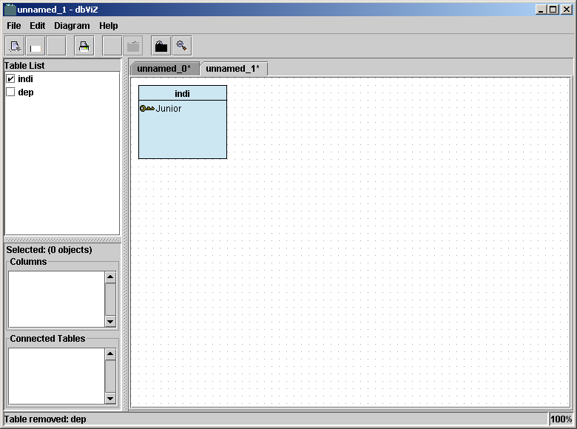
R. Make sure that:
    - The table doesn’t look smaller.
    - The zoom factor in the lower right corner says 100%
    - Edit/Auto Arrange option is unchecked.
    - The table list on the left side contains the right list of the table and the check boxes match the tables on the screen.
    - Edit/Undo displays the Undo Add Table indi.
    - Print Preview displays one table.
    - Print Prints the selected diagram.
    - Save saves the selected diagram.
- Add one more table to the new diagram.
  - The table will appear overlapping the first table.
- Remove the table from the diagram.
  - The table will disappear from the diagram.
- Click on the left tab to display the first diagram.
  - Make sure that:
    - The tables look smaller.
    - The zoom factor in the lower right corner says 67%
    - Edit/Auto Arrange option is checked.
    - The table list on the left side contains the right list of the table and the check boxes match the tables on the screen.
    - Edit/Undo displays the Undo Add Table dep.
    - Print Preview displays two tables.
    - Print Prints the selected diagram.
    - Save saves the selected diagram.

