dbViZ
Software Architecture Document

Version 1.5

Revision History
Date | Version | Description | Author
11/6/2002 | 1.0 | Initial version | Ross Paul
11/14/02 | 1.1 | Additions to the document | Sonia Kaura
11/15/02 | 1.2 | More Additions to the document | Sonia Kaura
11/18/02 | 1.3 | Add Viewing the Schema and Implementation. | Jianmei Fan
12/3/2002 | 1.4 | Reviewing the Software Architecture | Sonia Kaura
12/13/2002 | 1.5 | Reviewing the Software Architecture | Jianmei Fan

Table of Contents
1. Introduction 4
1.1 Purpose 4
1.2 Scope 4
1.3 Definitions, Acronyms, and Abbreviations 4
1.4 References 4
2. Architectural Goals and Constraints 4
3. Use-Case View 4
4. Logical View 6
4.1 Overview 8
4.2 Architecturally Significant Design Packages 8
5. Process View 8
6. Deployment View 8
7. Implementation View 9
7.1 Main 9
7.2 Import 9
7.3 Schema 10
7.4 GUI 11
8. Data View 13
9. Size and Performance 13
11. Quality 13

Software Architecture Document

Introduction

Purpose
This document provides a comprehensive architectural overview of the system, using a number of different architectural views to depict different aspects of the dbViZ system. It is intended to capture and convey the significant architectural decisions which have been made on the system.

Scope
The scope of this document will be focused on the use case view, logical view, and implementation view of the architectural design of the dbViZ System. We will identify important aspects of each view as well as the architectural significance each presents to the success of the dbViZ System.

Definitions, Acronyms, and Abbreviations
See the dbViZ Glossary

References
Use cases, package diagrams

Architectural Goals and Constraints
dbViZ is being developed as a Java based open source project whose repository resides on source forge. By using Java, the development team makes great use of the other open source projects which allows us to focus on primary functionality without getting bogged down on problems which have already been solved. Java also provides a simple means of distribution as the executable will run on any system which has an up to date JVM. Since its primary function will be as a tool for an individual user, security has not been considered during the design.

Use-Case View
The application dbViZ is a Visualization Tool for the existing Database, which may be very big in size. One of the main scenarios for the application is to give a sound, pleasant interface to the database that the user is studying. The user is mainly the “Database Analyzer” (our term for the person who has the authentication of viewing the database).
Some of the main Use-Cases that present the significance of the application are the:-
- Importing the Schema into the dbViZ.
- Create ER diagram.

These 2 main use-cases drive the application and are explained for appreciating the Use-Case view of the dbViZ.
Importing the Schema into the dbViZ
Preconditions: The application dbViZ is already installed and the user has special privileges for the installation of the application and its operation. These special privileges are needed because he will be accessing some important databases.
Main Scenario:
- The user (here after referred as the DBA) chooses to import the schema.
- DBA is asked the kind of the database of which the Schema is to be imported. Choices reflect the support that dbViZ provides for the various kinds of database and they can be :-
  - Importing the Schema from a file.
  - Improting the Schema from an Oracle Database
  - Importing the Schema from PostgreSQL .
  - Or any other database.

- After choosing the kind of the Schema, the user is asked the authentication information if required.
- The dbViZ connects to the appropriate Schema (file or actual database) and loads the schema in the application.
- The main view window of the application dbViZ opens showing the loaded schema (i.e. the tables etc in the database), a drawing area (for visualization of this schema) and the properties palette for properties of the schema.

More detailed main view window can be found in Vision.
Create ER diagram
Preconditions: The schema has been successfully loaded.
Main Scenario:
Add table:
- The user selects the checkbox beside the appropriate table in the Table List that the user wishes to add to the diagram (drawing area).
- Table name, its column names and its linked table names appear in the table information area.
- Application displays "Click on an empty area of the diagram to place the table." on the Status Bar.
- User chooses location on the diagram that they want the table to appear.
- The table appears on the diagram and is automatically selected.
- The application finds all connections for the table.
- The application draws the table's connections on the diagram, and italicizes the connected tables in the Table List.
- The application will display "Table added successfully." on the Status Bar.
Remove table:
- The user deselects the checkbox beside the appropriate table in the Table List that the user wishes to remove.
- Table name, its column name and its linked table name appear in the table information area.
- Message prompt appears on the screen asking if user wishes to remove the table.
- User confirms the selection.
- The application finds all connections for the table.
- The application removes the table's connections on the diagram and italicizes the connected tables in the Table List.
- The table disappears on the diagram and is automatically deselected.
- The application will display "Table removed successfully." on the Status Bar.
User repeats add table and remove table as many times as user like or is an option.

Logical View
Description of the Logical View
We clearly see from the description above that the application as a whole follows very closely the “Model View Control” or “MVC” model.
Here the Import and Schema are the modeling of the information read from the backend which is the Database. And the view is provided by the GUI and J-Graph. We can change the view of the information and can make any new view support the model of the read schema information.
Another pattern that clearly emerges out of the application is the “Factory Method” where we define the abstract interface for the Import and can later get the application to support any Database by just making it in to a separate class and implementing for this class the interface defined in the abstract class.
Thus the main segregation of the application dbViZ is on the “MVC” pattern is the
Model: consists of the components for Importing the Schema and Storing the Schema.
View: consists of the components for displaying the Chosen Schema on to the canvas.
GUI: is responsible for registering the events and sending it to the View so that it can update itself.

Therefore the application architecturally is divided into following packages:-
- Importer of the Database
- Schema
- GUI
- J-Graph.
Diagrammatically the interrelationship between the various packages is as given below:-

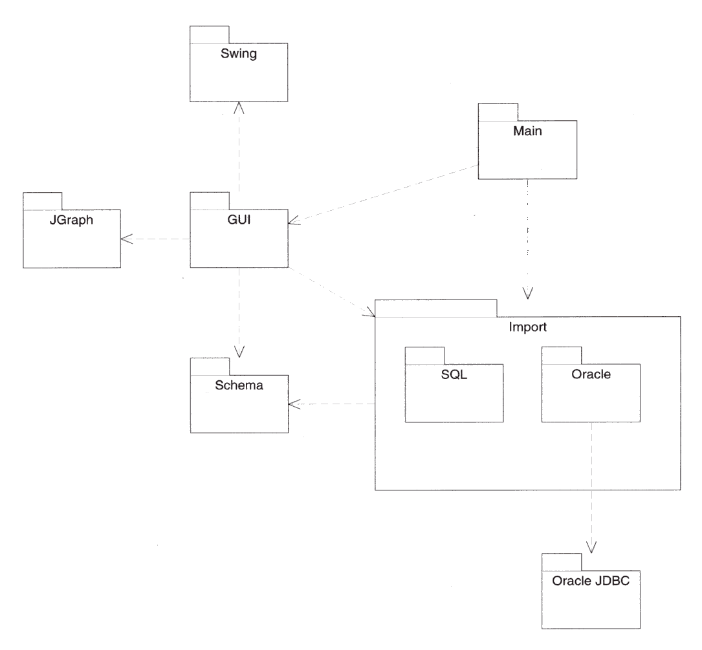

A brief description of the packages, its significance is presented below:-
1. Import: “Import of the Database” this package has an abstract class definition. The interface defined in this abstract class can be implemented as many databases as the application can support. Initially the application will support only the SQL File importer. By making an abstract interface to the specific database we effectively make the application extensible so that later additions in terms of the support of the database can be made without changing the architecture of the database.
2. Schema: Importer package handles the connectivity to the database and any error condition that arises from it. The Schema package provides the way to contain the information of the schema of the database so that it can be used by the GUI. This information present in the schema can it be read by the other GUI component of the application.
3. GUI: The GUI package reads the information from the Schema and then changes it into the format so that this information can be displayed in the format that makes the visualization of the database possible. And the chosen visualization is the E-R Diagram.
4. J-Graph: It is the function of this component to actually make the drawings of the E-R representing the schematic components of the database and display it at appropriate place in the application. Important to note hear is that the drawing canvas to which the J-Graph draws the components is event driven and so is the rest of the parts of the whole GUI. For e.g. If the user clicks on the table and then drags the icon to the canvas the drawing of the table in form of the E-R would be made on he canvas, along with its attributes, also when another table is chosen the canvas updates itself showing the constraints between the tables (if present) on the drawing canvas.

Overview
This section provides details for the main packages in the dbViZ application and their primary functions. In addition it details some of the major components in the packages, which drive the system.

Architecturally Significant Design Packages
dbViZ’s architecture was designed to maximize package cohesion and minimize the coupling between packages. To this effect, the main functionality is divided between:
- Schema – This package contains the classes that represent a schematic model of the database being analyzed. In some ways these classes are glorified structures whose purpose is simply to allow the GUI to access an internal representation of a databases schema rather than communicate directly with a database. Most importantly the Schema is database neutral and can support the storing of information of almost any kind of database.
- Imports – Conceptually, this package is the link between an external schema the internal Schema package. Partially abstract, it defines the interfaces needed to import a schema while leaving the details of the importation process to specific sub-packages. These sub-packages can import schemas from a variety of sources; initial sources being a sql file and an Oracle database.
- GUI – The Graphical User Interface provides the user a means to view details of an imported schema. Its main purpose is to provide an intuitive means for viewing foreign key restraints between tables. The primary components of the GUI will be the diagram panel, the table list, the table detail, and the status bar.

Process View
We realize that our application cannot be described using this view. This section is left is any revisions are needed later.

Deployment View
Deployment of is a fairly simple matter. Designed with Java 1.4, it will run on any system with a modern JVM. While the main application is simple to deploy, allowing the system to make full use of it’s schema importing features will require knowledge about the environment where it is being used. The basic importation method, reading in a SQL file, is trivial as it only requires a prompt for the user to specify the location of the file. Importation from live databases however, requires more specific knowledge about the computing environment such as database driver location, remote querying permissions, and port numbers. Methods to facilitate these complexities are TBD.

Implementation View

As shown in the package diagram, dbViZ organized into Main, Import, Schema, and GUI packages. The more detail of implementation of these packages is presented below:

Main
Main has two major functions: Main marks commencement of the application. Main package (JDBV class) loads the main GUI and initializes the ImportRegistry. The import details such as username and password are handled by the individual ImportDefinition implementations.

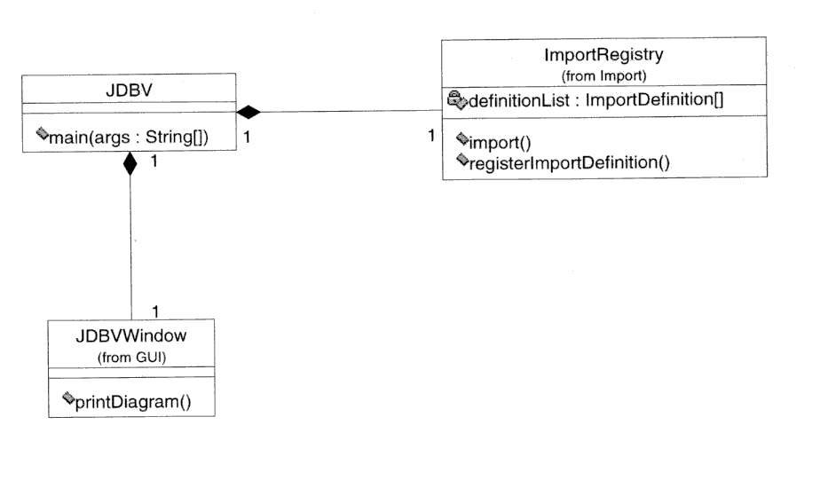

Import
The abstract ImportDefinition can be implemented to handle importing in many different ways, such as by connecting to a database, or reading SQL file or some other kind of data file. All of these importDefinitions are registered with the ImportRegistry (not abstract). The GUI implemention for ImportDefinition and ImportRegister are ImportPanel and ImportRegisterWindow.
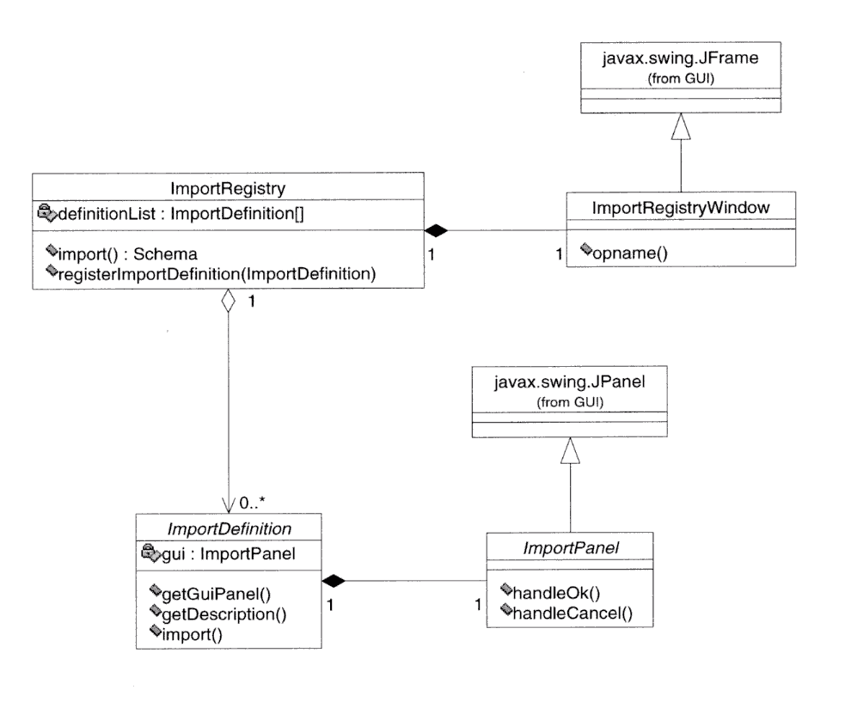

Schema
The schema is composed of tables, while table is composed of columns. Connection determines how tables link together by using foreign key relationships. Schema classes are instantiated by implementations of ImportDefinition.

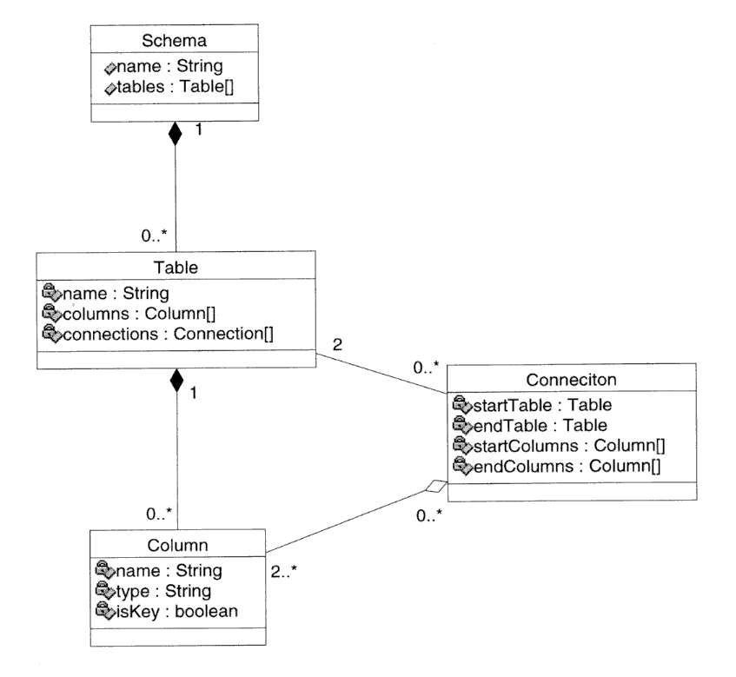

GUI

GUI lets user handle the import process, view diagram, process diagram, and print diagram. GUI components are JGraph and Swing APIs, which includes JScrollPane, JComponent, JPanel, JTabbedPane, and JFrame. For more convenience, part of the GUI - import process has been put in the Import package. The proposed diagram should look like this:
The printed diagram consists of TableInformation, TableList, DiagramPane, and StatusBar. TableInformation gives current table name, its column name, and its linked table name. TableList shows all tables’ name. Connected tables will be italicized in the Table List. Main diagram area is DiagramPane. Diagram component (column, table, connection) and schema are two major attributes of Diagram. StatusBar shows current action on the Diagram.
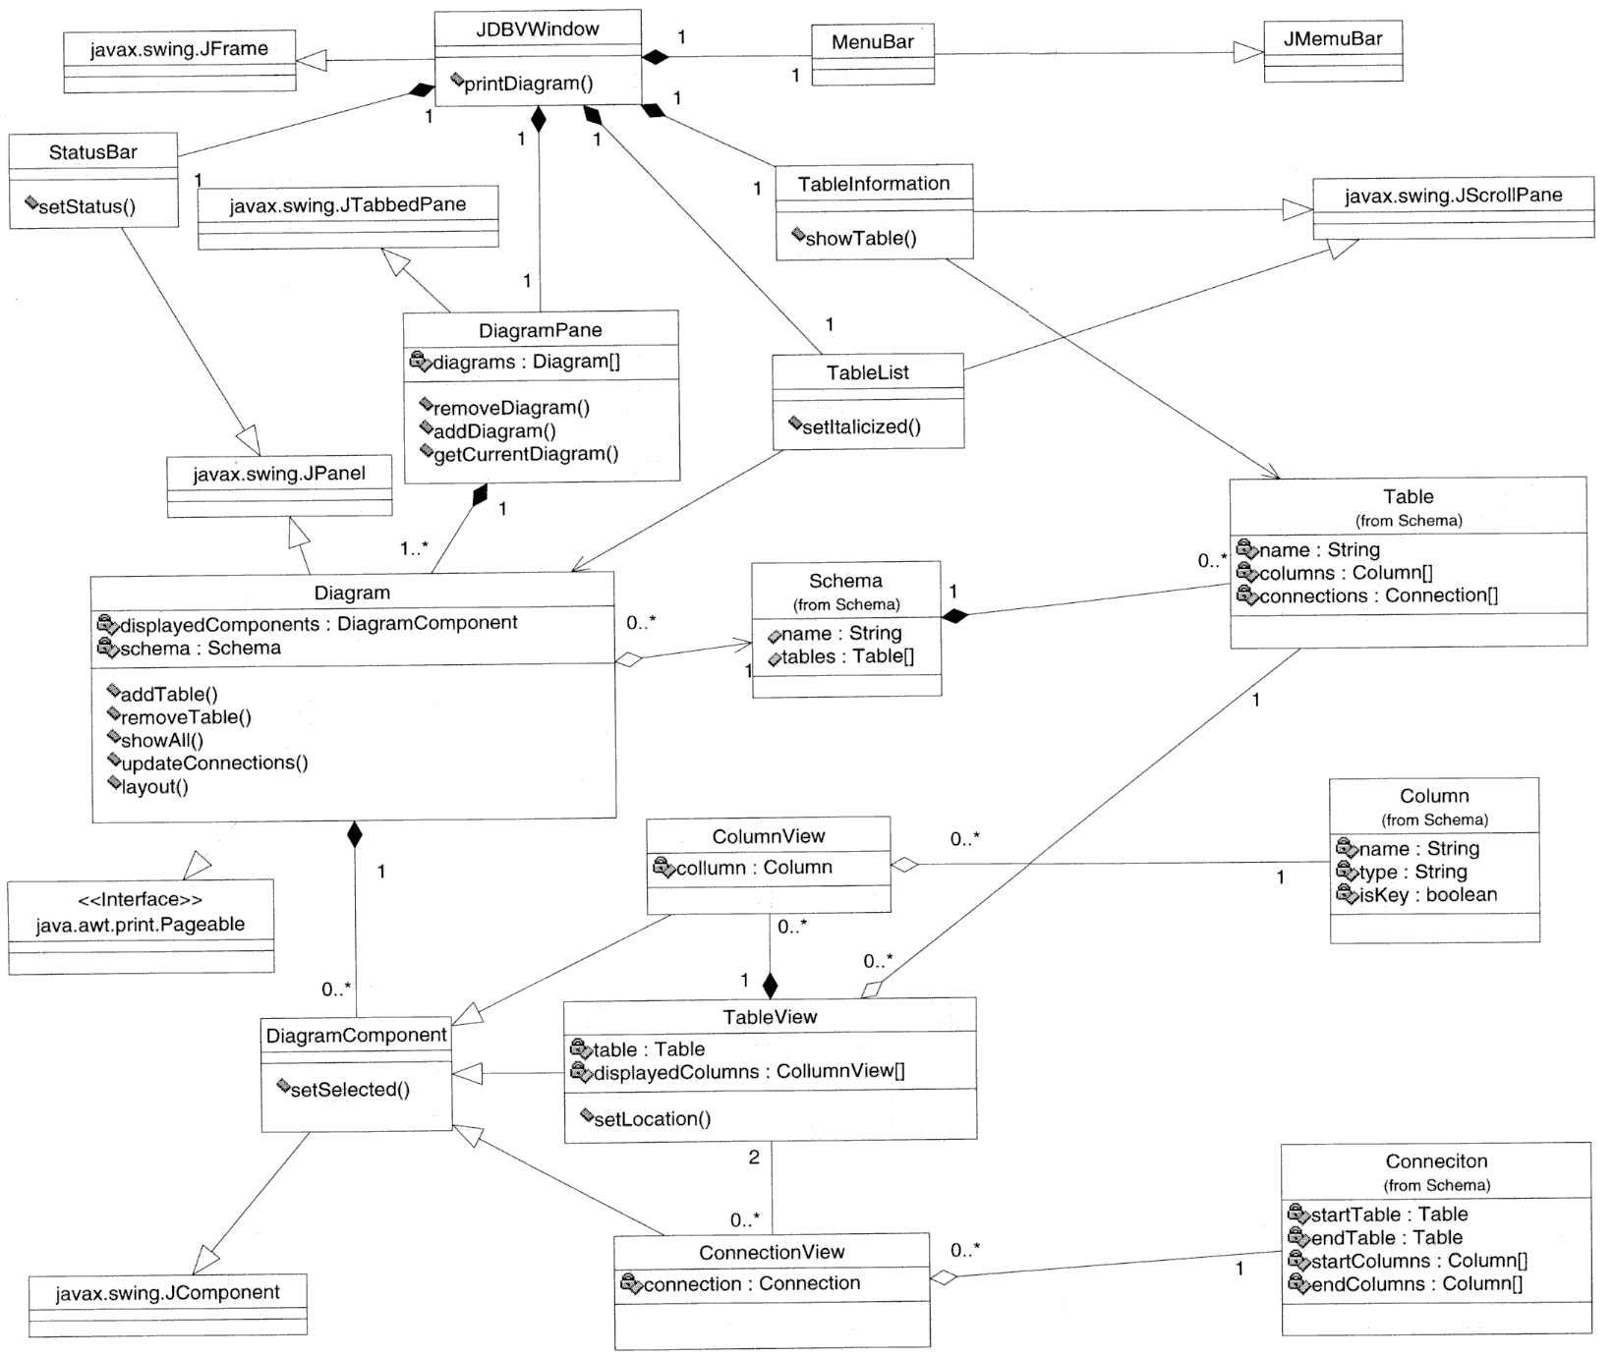

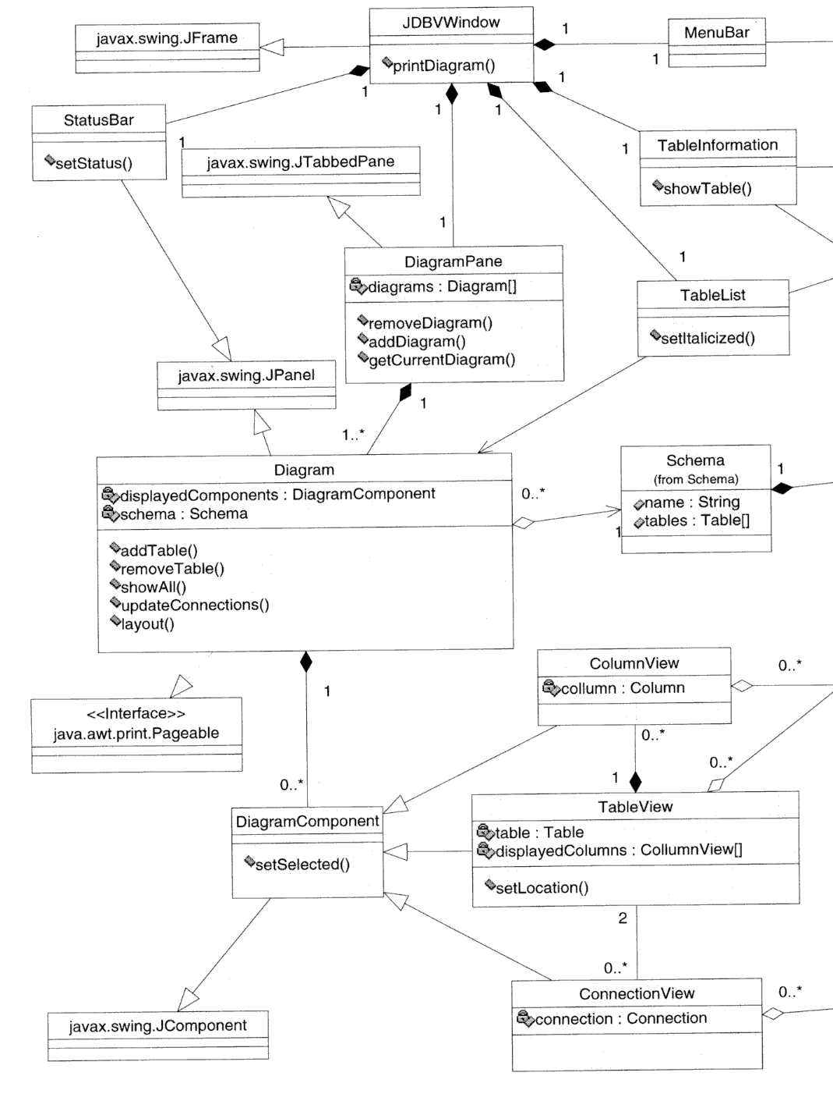
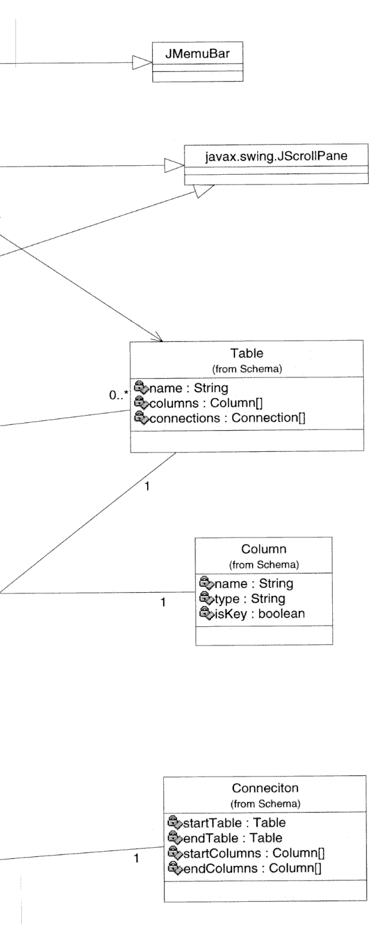

Data View
The primary data in dbViZ is stored in the schema package, which details the tables, columns, and the relationships between the tables (foreign keys). In addition, information concerning what is being shown in the database diagrams (which tables, and connections) as well as location information will be stored in the diagram panel.

Size and Performance
Following are some of the assumption and numbers related to the size and the performance of the application in question.
- We envisage that the class files will be up to 10 MB in size. Though its attempted that the size is less making it a light application, light to download and use.
- The above said size does not include the size of the JVM.
- It will fit in a 64MB memory footprint when a 40-table schema and diagram are loaded.
- The performance numbers given in use cases (such as the 20 second startup time) are when run on a 500MHz x86 processor.

Quality
This application is not extremely reliable and must not be used in critical applications. It is cross platform. It is easily extensible as far as adding new importers. It has no security requirements since it depends on Operating system and database security features. It has no privacy issues, as it is a single-user application.

